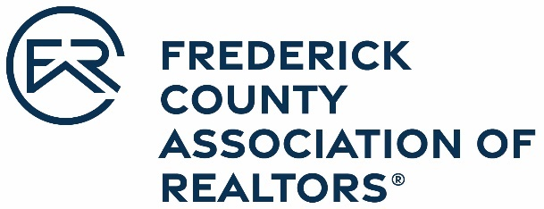

OFFICIAL ENTRY FORM
Frederick County Association of REALTORS®
2021 Affiliate Shining Star Award
Nominations are due April 1, 2022

The Affiliate Shining Star Award is presented to a new committee volunteer who demonstrates outstanding commitment and enthusiastic support to FCAR programs. Nominations for this award will come from FCAR Committee chairs and FCAR staff.

Nominee Name: _
Office: __ _
Address:

Please attach a brief narrative that explains the nominee’s accomplishments and include the information in the following categories:
- Length of time in the profession
- Reason(s) for nomination this person
Nominated by:

Committee:
Office Manager/Broker: _
Office Name: _
Nominee Signature: __________________________________________________________

Frederick County Association of REALTORS® 478 Prospect Blvd.
Frederick, MD 21701 www.fcar.org | info@fcar.org | 301-663-0757

