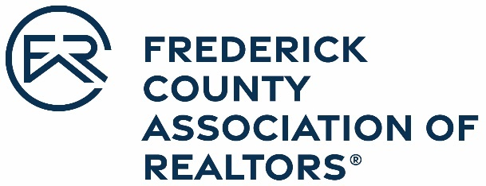

OFFICIAL ENTRY FORM
Frederick County Association of REALTORS®
2021 Realtor Lifetime Achievement Award

Nominations are due April 1, 2022

The Frederick County Board of REALTORS® may annually bestow the Realtor Life Achievement Award, which recognizes extraordinary contributions to the real estate profession and to the REALTOR organization.

Nominee Name: _
Office: _
Address:

Please attach a brief narrative that explains the nominee’s accomplishments in each of the following categories:
- At least 25 years of active full-time service in real estate (any capacity).
- Still active in the real estate profession.
- Demonstrated throughout his/her career extraordinary and outstanding leadership and contributions to the real estate profession, and to the REALTOR® organization at the state and local level. Widely acknowledged by professional colleagues for the highest level of professional competence and personal and professional ethics and general reputation.
- Outstanding contributions to the business community, generating recognition, respect, and enhanced regard for the real estate profession among business and civic leaders.
Nominated by: ______

Office Manager/Broker: _______
Office Name: _______
Nominee Signature: _

Frederick County Association of REALTORS® 478 Prospect Blvd.
Frederick, MD 21701 www.fcar.org | info@fcar.org | 301-663-0757

