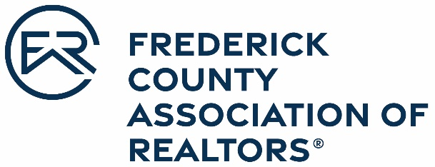

OFFICIAL ENTRY FORM
Frederick County Association of REALTORS®
2022 Affiliate of the Year

*Nominees are only eligible if he/she is an FCAR Affiliate member
in good standing

Nominations are due March 31, 2023

The lenders, title companies, attorneys, inspectors, appraisers, surveyors, and many others who provide products and services to our industry are sometimes overlooked. There are always a few of these people who seem to do a little more, go the extra mile and are always there to lend a helping hand.

Affiliate members often donate many hours and dollars to FCAR functions, provide exceptional service and excel as professionals. They are well-regarded for their fair business practices and ethical conduct. They serve the community in a variety of ways, from their membership in civic and community groups to heading fundraisers for specific causes.

Nominee Name: _____________________________________________________________
Office: _____________________________________________________________________
Address: ___________________________________________________________________
___________________________________________________________________

Please attach a brief narrative that explains the nominee’s accomplishments in the following categories:

- Service on FCAR Committees
- Fair Business Practice and Affiliate Spirit
- Maryland REALTORS® Involvement
- Community Service
- Business Accomplishments (including professional knowledge)
- Sponsorship of Education and other programs for REALTORS®

Nominated by: _________________________________________________________________

Nominee Signature: _____________________________________________________________

